General Engineering Erection, Fabrication & Maintenance

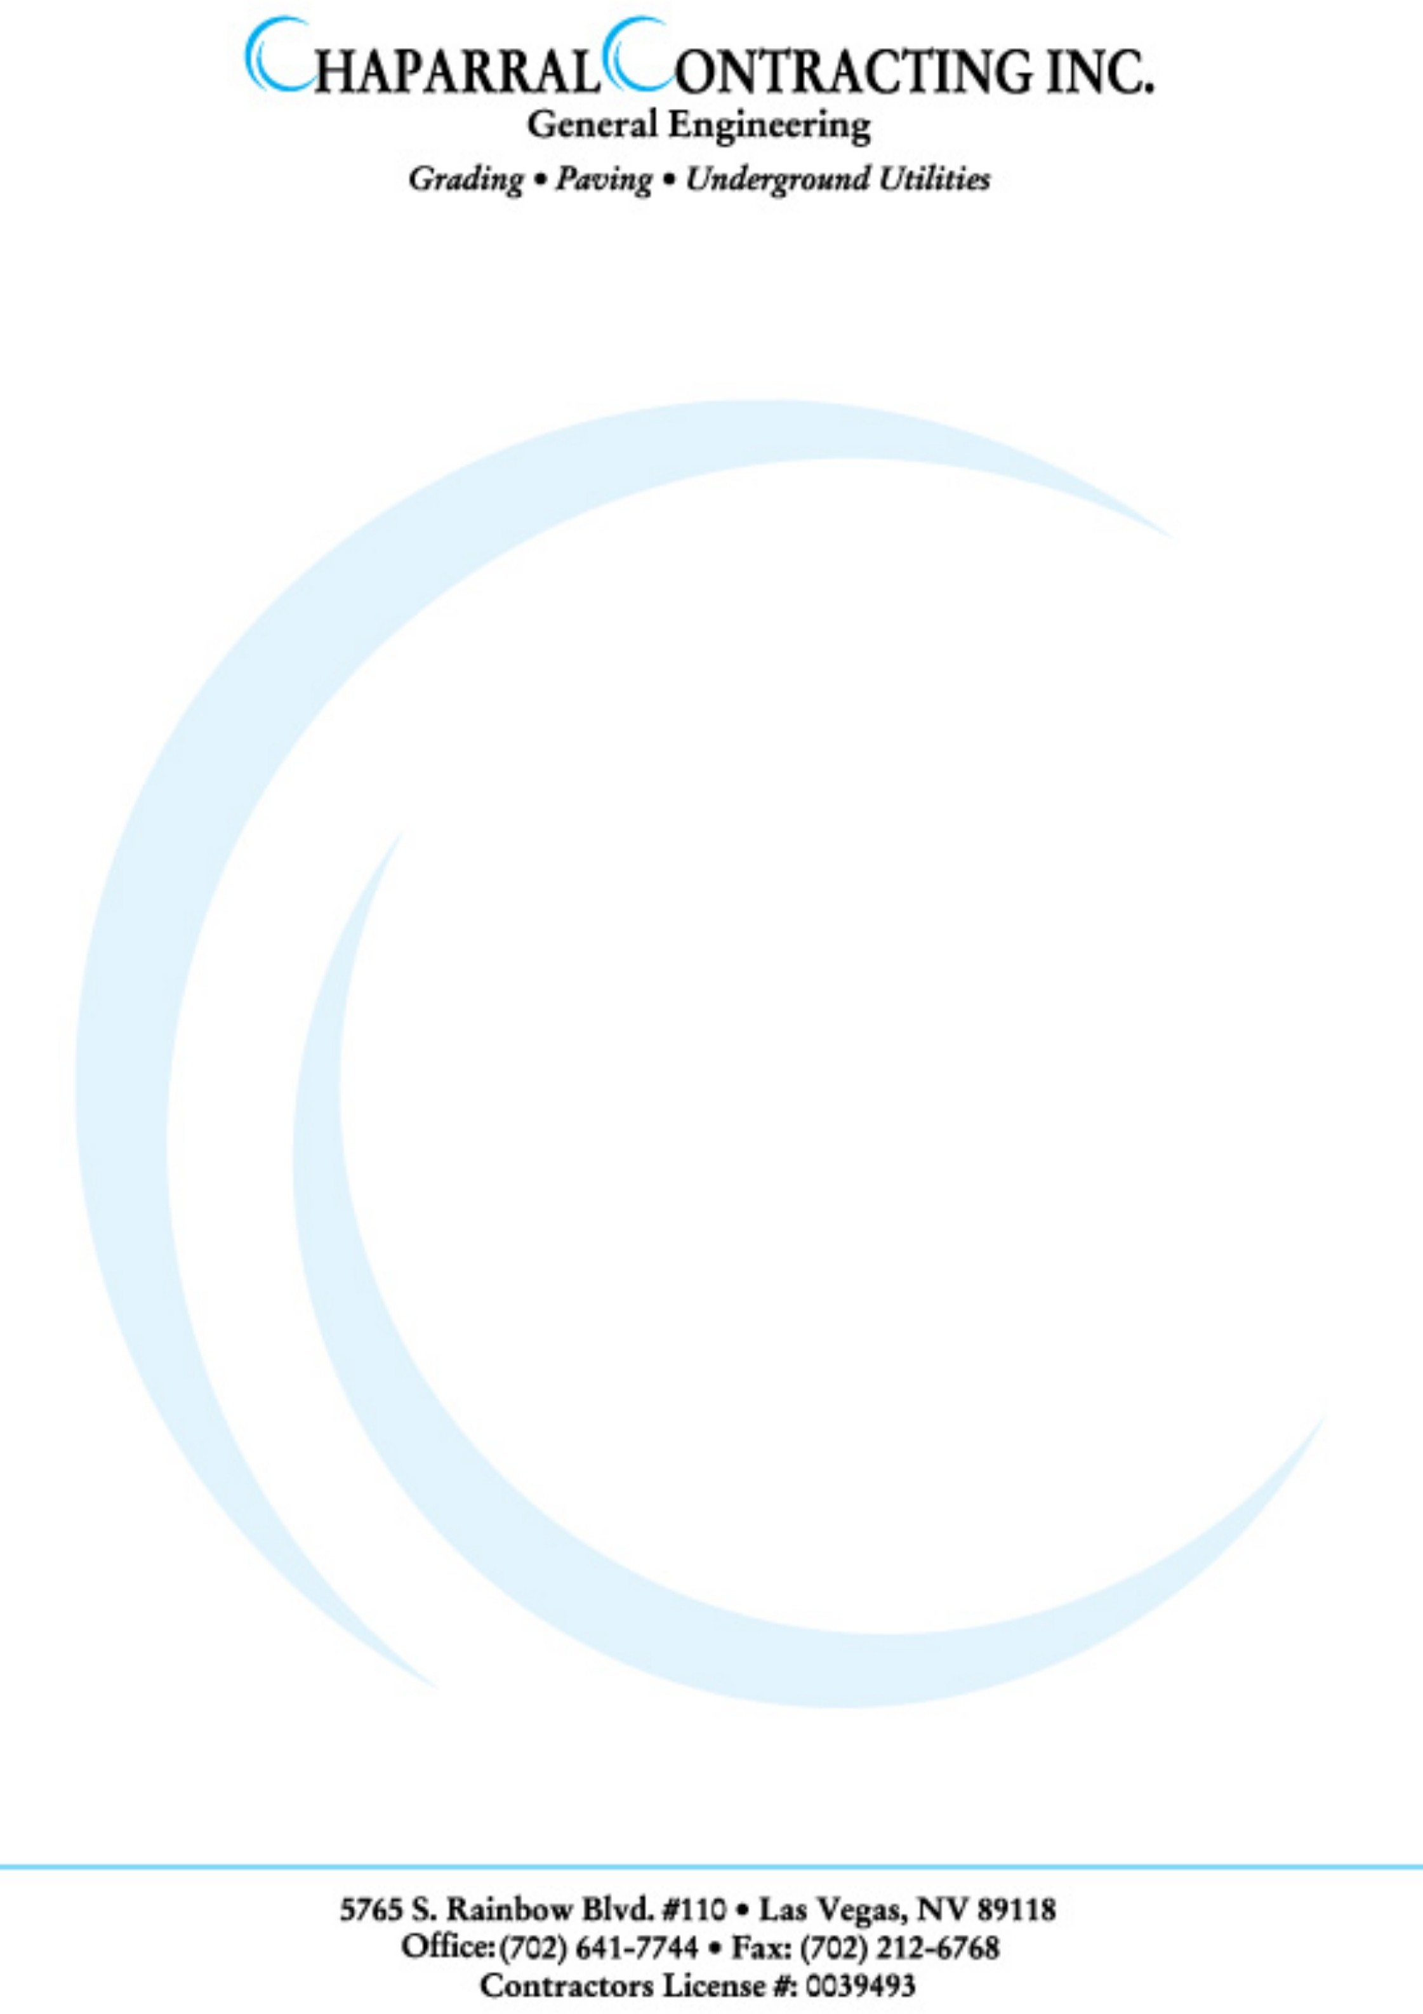

##### EXPERIENCE CERTIFICATE

It is certify that Mr. <Name> S/O Mr. <fname> work with us as <Designation> at Ibrahim Textile Mills Limited Faisalabad from <From> to <To>.

He proves his self to be right man for the post <Designation>. During his working period we found very Hardworking, Co-operative, Honest and Dutiful in his Job. He is very obedient and hardworking person.

We wish him success in his future life.

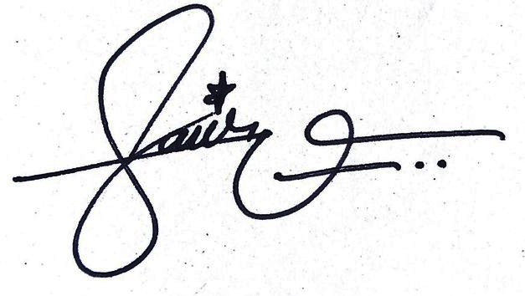

## For

Chaparral Contracting

###### Ali Arcade, 1st Floor, Bismillah Chowk, District Sheikhupura.